1. Read mobile dataset using pandas, and preprocess it (fill null values).
2. Draw correlation graph for mobile price with all attributes.
3. Compute outer product of 2 vectors.

Eg:

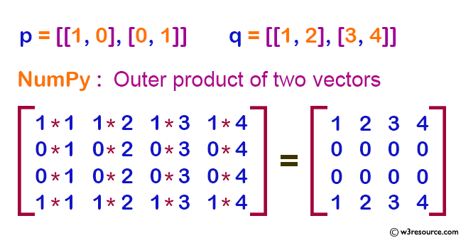

original matrix:

[[1, 0], [0, 1]]

[[1, 2], [3, 4]]

Outer product of the said two vectors:

[[1 2 3 4]

[0 0 0 0]

[0 0 0 0]

[1 2 3 4]]

1. Write a NumPy program to compute the condition number of a given matrix.
2. Original matrix:
3. [[1 2]
4. [3 4]]
5. Condition number of the said matrix:
6. 14.9330343737

5. write a NumPy program to compute the sum of the diagonal element of a given array(matrix).